Machine Problem (Python): Problem 2

Python Script

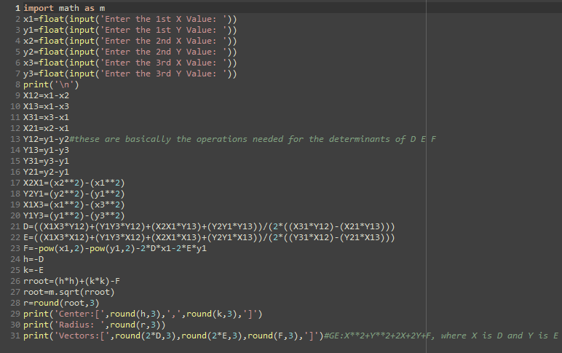

Inputting Values and outputting the Center, Radius, and Vectors D E F of the circle

